Assignment
Fundamental Theory
(LAB: 8)
NAME: Majid Ali
CMS ID: 053-25-0017
PROGRAM: Software engineering (Section: A)

Q 1:
Calculator Operations (+,-,*,/,%) Just like the sample program discussed in the class that was performing the addition of two numbers, create four (04) separate functions, each of which gets two integer values as parameters and returns the subtraction, multiplication, division, and modulus (remainder) of those two values, respectively. Then call these functions in the main () function and print the values returned by them. Note: Each user-defined function should only return a value after performing the respective arithmetic operation. The remaining logic, which prints the results, should be put in the main () function.
#include <iostream>
using namespace std;
int operation(int num1,int num2,char sign){
int Add,sub,mul,divi;
if(sign=='+'){
Add=num1+num2;
cout<<"Addition is:"<<Add<<endl;}
else if(sign=='-'){

sub=num1-num2;
cout<<"subtraction is:"<<sub<<endl;}

else if(sign=='*'){

mul=num1*num2;

cout<<"Multiplication is:"<<mul<<endl;}

else if(sign=='/') {

divi=num1/num2;
cout<<"Division is:"<<divi<<endl;}
else
cout<<"Invalid";
return 0;}
int main(){
int num1,num2;
char sign;
cout<<"Enter the num1: ";
cin>>num1;
cout<<"Enter the operation: ";
cin>>sign;
cout<<"Enter the num2: ";
cin>>num2;
cout<<"RESILT: ";
operation( num1,num2, sign);
return 0;
}

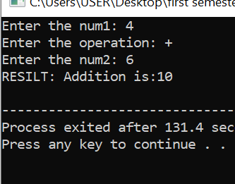

Q 2:
Power:
Write a C++ program that defines a function power to calculate the power of a number. The program should take two user-defined values, the base, and the exponent, and use the power function to compute the result. The function should be defined as follows: double power (double base, int exponent) { // Implement the logic to calculate the power of the base raised to the exponent. // Return the result as a double. } Here are the steps for the task: - Define a C++ program that includes the power function as described above. - In the main function, prompt the user to input the base and the exponent. - Call the power function with the user-provided values and display the result. - Ensure that the program handles integer exponents and calculates the result correctly. For example, if the user inputs a base of 2 and an exponent of 3, the program should correctly calculate and display that 2^3 is equal to 8. You can modify the program as needed and add appropriate error handling or validation for the user inputs
#include <iostream>
using namespace std;
int power(int base,int exponent){
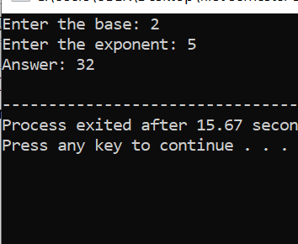
long long result=1;
int i;
for(i=1; i<=exponent; i++) {
result*=base;
}
return result;}
int main(){
int base,exponent;
cout<<"Enter the base: ";
cin>>base;
cout<<"Enter the exponent: ";
cin>>exponent;
cout<<"Answer: "<<power(base,exponent)<<endl;
return 0;
}

Q 3:
Greater Finder:
Create a function that takes two integer values as parameters and returns the greater value of those two. Then, call that function in the main () and display the result. Note:
We are assuming that the values of parameters will be unique (the caller will NOT give the same value for both parameters)
#include <iostream>

using namespace std;
int greater(int num1,int num2){
if(num1>num2){
cout<<"Number one is grater "<<endl;
}
else
cout<<"Number two is grater"<<endl;
}

int main(){
int num1,num2;
cout<<"Enter the number one: ";
cin>>num1;
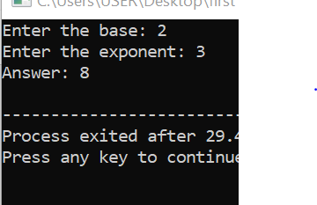
cout<<"Enter the number two: ";
cin>>num2;
cout<<"Result"<<greater(num1,num2)<<endl;

return 0;
}
Q 4:
Factorial:
Create a function that takes one integer value as a parameter and then returns the Factorial of a non-negative integer. After that, call that function in the main () and display the result.
#include <iostream>
using namespace std;
int factorial(int n){
int i,fact=1;
for(i=1; i<=n; i++){
fact*=i;
}
return fact;
}
int main(){
int num;
cout<<"Enter the number: ";
cin>>num;
cout<<"Factorial is: "<<factorial(num)<<endl;
return 0;
}

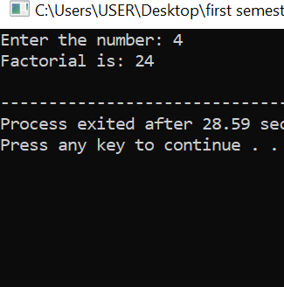

Q 5:
Even or Odd:
Create a function that takes one integer value as a parameter and then return the word Even (if that number is an even number) or Odd (if the value is odd). After that, call that function in the main () and display the result.
#include <iostream>
using namespace std;
int checker(int num){
if(num%2==0){
cout<<"Even"<<endl;
}
else
cout<<"Odd"<<endl;
return num;
}
int main(){
int num;
cout<<"Enter the number: ";
cin>>num;
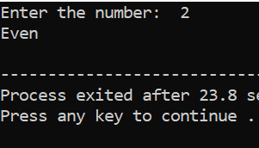
checker(num);
return 0;
}

Q 6:
Number is Prime or Not:
Create a function that takes an integer value as a parameter and returns a boolean value (true or false) depending on whether the parameter value is prime or not. If that value is prime, the function should return true; otherwise, it should return false. In the end, call that function in the main () function by passing a value taken as input from the user, and depending on the returned value, print whether the number is prime or not. For example, Note: The user-defined function should only return a boolean value (true or false). The remaining logic, which prints the respective message whether a number is prime or not, should be put in the main () function.
#include <iostream>
using namespace std;
bool isprime(int num){
if(num<=1)
return false;

for (int i=2; i<num; i++){
if(num%i==0)
return false;
}
return true;
}
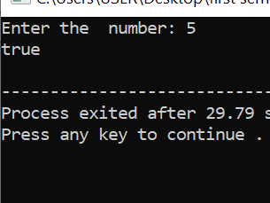
int main(){
int num;
cout<<"Enter the number: ";
cin>>num;
cout<<boolalpha <<isprime(num)<<endl;
return 0;
}

Q 7:
Write a C++ program that defines a function display to show the information. The program should take four user-defined values, i.e., int id, string name, double salary, and char gender. The function should be defined as follows: void display (int id, string name, double salary, char gender); In main() you need to take these values from the user and then display them by calling the display function.
#include <iostream>
using namespace std;
void display(int id,string name, double salary,char gender){
cout << "\n--- Employee Information ---" << endl;
cout << "ID: " << id << endl;
cout << "Name: " << name << endl;
cout << "Salary: " << salary << endl;
cout << "Gender: " << gender << endl;
}
int main(){
int id;
string name;
double salary;
char gender;
cout<<"Enter the id: ";
cin>>id;
cout<<"Enter the name: ";
cin>>name;
cout<<"Enter the salary: ";
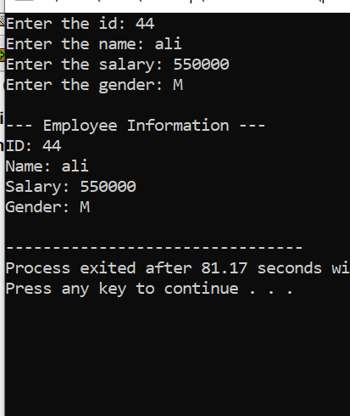
cin>>salary;
cout<<"Enter the gender: ";
cin>>gender;
display(id,name,salary,gender);
return 0;
}
Q 8:
Percentage Calculator:
Create a function that computes the percentage of a student. The function should take two values (obtained marks and total marks) as parameters and return the percentage (that can be a value with a decimal point). Then, call that function in the main () by passing two values to it, and display the result.
#include <iostream>
using namespace std;
int percentage(int obtain_marks,int Total_marks){
float percentage;
percentage=(float)obtain_marks/Total_marks*100;
return percentage;
}
int main(){
int obtain_marks,Total_marks;
cout<<"Enter the obtain marks: ";
cin>>obtain_marks;
cout<<"Enter the Total marks: ";
cin>>Total_marks;
cout<<"Your percentage is: "<<percentage(obtain_marks,Total_marks)<<"%"<<endl;
return 0;
}

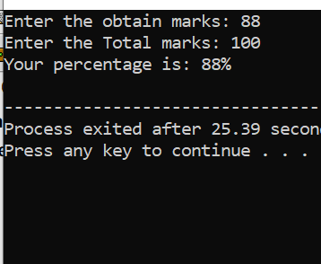

Q 9:
Grade Calculator:
Create a function that takes the percentage (a value that might contain value with decimal point) as a parameter and returns the grade (A, B, C, or F). The rules for calculating the grade are: i. If the percentage is between 80 and 100 (inclusive), the grade will be A ii. If the percentage is between 70 and 79, the grade should be B iii. If the percentage is between 60 and 69, the function should return the grade C iv. If the percentage is less than 60, the grade will be F Then, call that function in the main () by passing the percentage and show/display the result/grade returned by the function.
#include <iostream>
using namespace std;
int grade(int obtain_marks, int Total_marks){
float percentage;
percentage=(float)obtain_marks/Total_marks*100;
if(percentage>=80 && percentage<=100)
cout<<"A"<<endl;
else if (percentage>=70 && percentage<=79)
cout<<"B"<<endl;
else if (percentage>=60 && percentage<=69)
cout<<"c"<<endl;
else
cout<<"F"<<endl;
return percentage;
}
int main(){
int obtain_marks,Total_marks;
cout<<"Enter the obtain marks: ";
cin>>obtain_marks;
cout<<"Enter the Total marks: ";
cin>>Total_marks;
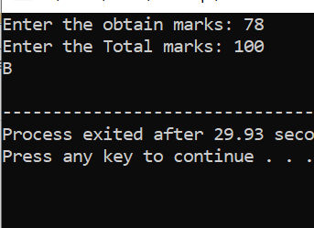
grade( obtain_marks, Total_marks);
return 0;
}

Q 10:
Create a user-defined function that takes on parameter range and returns the sum of all positive integers up to that range. For example,
#include <iostream>
using namespace std;
int sum(int range){

int sum=0;
for(int i=1; i<=range; i++){
sum+=i;
}
return sum;
}

int main(){
int range;
cout<<"Enter the range which want to sum: ";
cin>>range;
cout<<"Sum of all "<<range<<" positive integer is: "<<sum(range)<<endl;
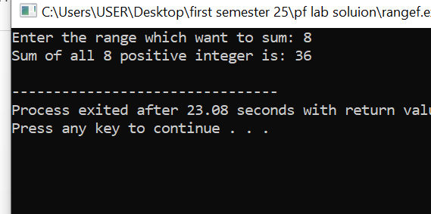
return 0;
}

Q 12:
Create an overloaded displayInfo function that can take different numbers and types of arguments to display information about a person. Requirements:
• void displayInfo(string name) – prints "Name: [name]".
• void displayInfo(int age) – prints "Age: [age]".
• void displayInfo(string name, int age) – prints "Name: [name], Age: [age]".
#include <iostream>
using namespace std;
void display(string name){
cout<<"Name: "<<name<<endl;
}
void display(int age){
cout<<"Age :"<<age<<endl;
}
void display(string name,int age){

cout<<"Name: "<<name<<" Age: "<<age<<endl;
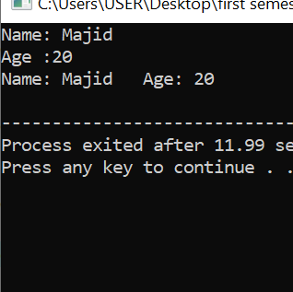
}
int main(){
display("Majid");
display(20);
display("Majid",20);
return 0;
}

Q 11:
Create a function calculateArea that calculates the area of different shapes (circle, rectangle, and triangle) using function overloading. Requirements: • Circle: double calculateArea(double radius) – takes one argument (radius) and returns the area of a circle. Area = πr² • Rectangle: double calculateArea(double length, double width) – takes two arguments (length and width) and returns the area of a rectangle. Area = length * width • Triangle: double calculateArea(float base, float height) – takes two arguments (base and height) and returns the area of a triangle. Area = 1/2 * base * height
#include <iostream>
#include <cmath>
using namespace std;

double calculateArea(double radius) {
return 3.15 * radius * radius;
}

double calculateArea(double length, double width) {
return length * width;
}

double calculateArea(float base, float height) {
return 0.5 * base * height;
}

int main() {
double radius, length, width;
float base, height;
cout<<"Enter radius of circle: ";
cin>>radius;
cout << "Area of Circle: "<< calculateArea(radius)<<endl;
cout<<"\nEnter length and width of rectangle: ";
cin>> length >> width;
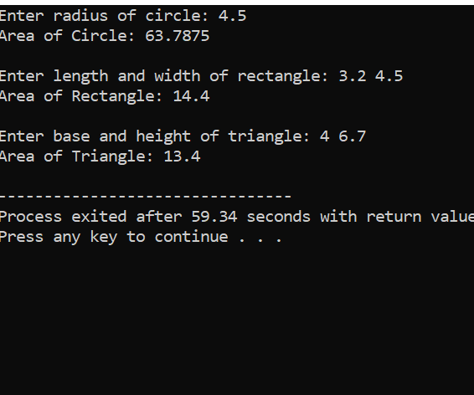
cout<<"Area of Rectangle: "<< calculateArea(length, width)<<endl;

cout<<"\nEnter base and height of triangle: ";
cin>>base>>height;
cout<<"Area of Triangle: "<<calculateArea(base, height)<< endl;

return 0;

